Preliminary model for laser projection kinematics

Owen Lu

Electroimpact Inc.

owenl@electroimpact.com

*Abstract*—This document

# Introduction

This project has been undertaken in order to hopefully develop better solving algorithms for the laser scanners. It has been historically noted that registration order of calibration points can create performance variations. This is not ideal as the input data set should result in one solution describing the location and orientation of the system.

# Axis definitions

The construction of the laser projector allows good choices for the axes to be made in order to simplify calculations. The rotational axes are assumed orthogonal to one another from one another.

We select the first stage mirror to have rotational axis along the Z-axis while the second stage mirror has axis along the X-axis. Thus, the first stage mirror rotates about the origin.

# Relative kinematics

Assume that the mirror is a mathematical plane. The laser is then reflected about its surface.

The laser path can be described as a piecewise 3D curve with each piece being a line.

Thus, what matters is the intersection point of the lines and the reflection planes, and the location of the final projected point in 3D space.

Suppose that $\hat{u}={\left[\begin{matrix}1 & 0 & 0\end{matrix}\right]}^{T}$ which represents the laser. Given angle $θ_{1}$, the smallest angle between the plane and the X-axis, the reflection transformation can be applied.

Since the mirror rotates along the Z-axis, we can use the rotation transformation matrix in two dimensions to find the x-y components.

$$\hat{u}'={\left[\begin{matrix}\cos\left(2θ_{1}\right) & \sin\left(2θ_{1}\right) & 0\end{matrix}\right]}^{T}$$

Now since the vector $\hat{u}'$ does not lie in the z-y plane, we cannot use the same trick to find $\hat{u}''$. An equation to find the vector after reflection about a plane with normal vector $\hat{n}$ is given below. All quantities are expected to be normalized.

$$r=d-2\left(d⋅n\right)n̂$$

Suppose that $θ_{2}$ is the smallest angle between the second plane and the Y-axis.

Then the second normal vector ${\hat{n}}_{2}$ can be written in terms of $θ_{2}$

$${\hat{n}}_{2}={\left[\begin{matrix}0 & -sin⁡(θ_{2}) & cos⁡(θ_{2})\end{matrix}\right]}^{T}$$

Performing the computation and simplification gives $u^{''}$

$${\hat{u}}^{''}=\left[\begin{matrix}\cos\left(2θ_{1}\right) \\ \sin\left(2θ_{1}\right)cos⁡(2θ_{2}) \\ \sin\left(2θ_{1}\right)\sin\left(2θ_{2}\right)\end{matrix}\right]$$

$$p_{2}={\left[\begin{matrix}\operatorname{Lcot}\left(2θ_{1}\right) & L & 0\end{matrix}\right]}^{T}$$

Suppose that we wish to model the projection of the laser on $z=k$.

We can generate some plot with the following equations with $θ_{1},θ_{2}$ pairs.

$$X=\cot\left(2θ_{1}\right)\left(L+K\csc{(2θ_{2})}\right)$$

$$Y=L+\cot{(2θ_{2})}$$

Using $L=0.05$ and $K=3$ the below projection plot was generated.

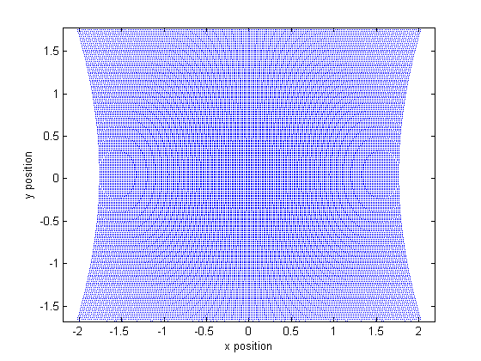

Figure 1 – Projection points using $30<θ_{1},θ_{2}<60$

Therefore, the line used to solve for the intersection of the laser and the surface is given below.

$$p_{2}+s\hat{u}''$$

# Error analysis

Assume that the mirror is a mathematical plane. The laser is then reflected about its surface

$$X=L\cot{(2θ_{1})}+\frac{K\cos{(2θ_{1})}}{\sin\left(2θ_{1}\right)\sin\left(2θ_{2}\right)}$$

$$Y=L+\frac{K\sin{(2θ_{1})}cos⁡(2θ_{2})}{\sin\left(2θ_{1}\right)\sin\left(2θ_{2}\right)}$$

Using the partial derivatives of

# Added mirror thickness model

Assume that the mirror is a mathematical plane. The laser is then reflected about its surface